**GOMP DEPLOYMENT FOR AWS RDS-DMS-ON-PREMISE**

1. **GO TO AWS – DATA MIGRATION SERVICE**

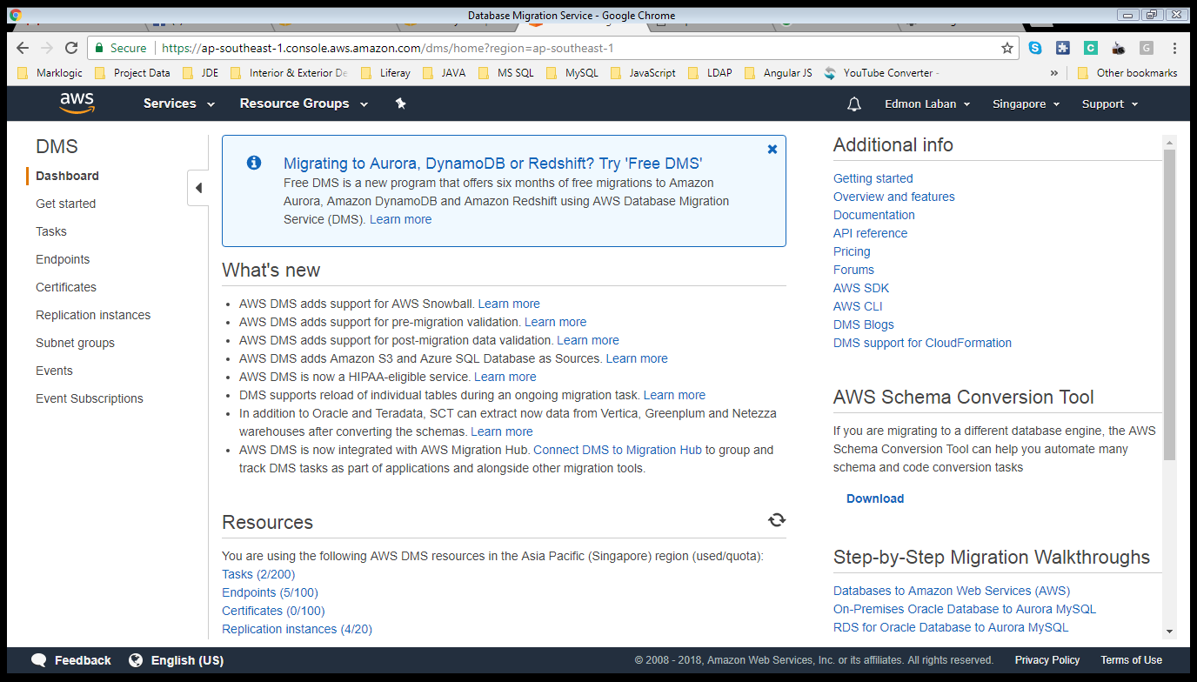

1. **GO TO REPLICATION INSTANCES**

**Click the Replication instances of the left side menu.**

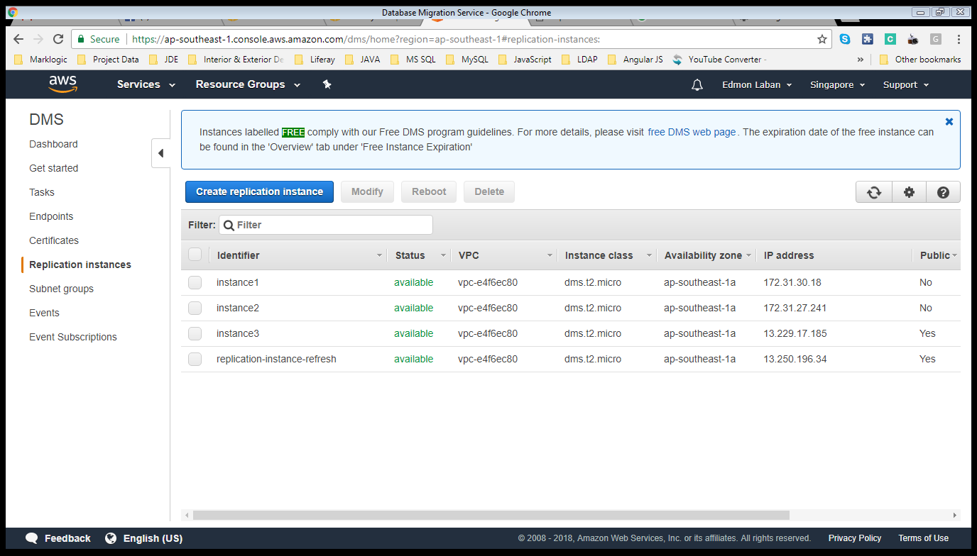

1. **CREATE REPLICATION INSTANCE**

**Click replication instance button to create new instance.**

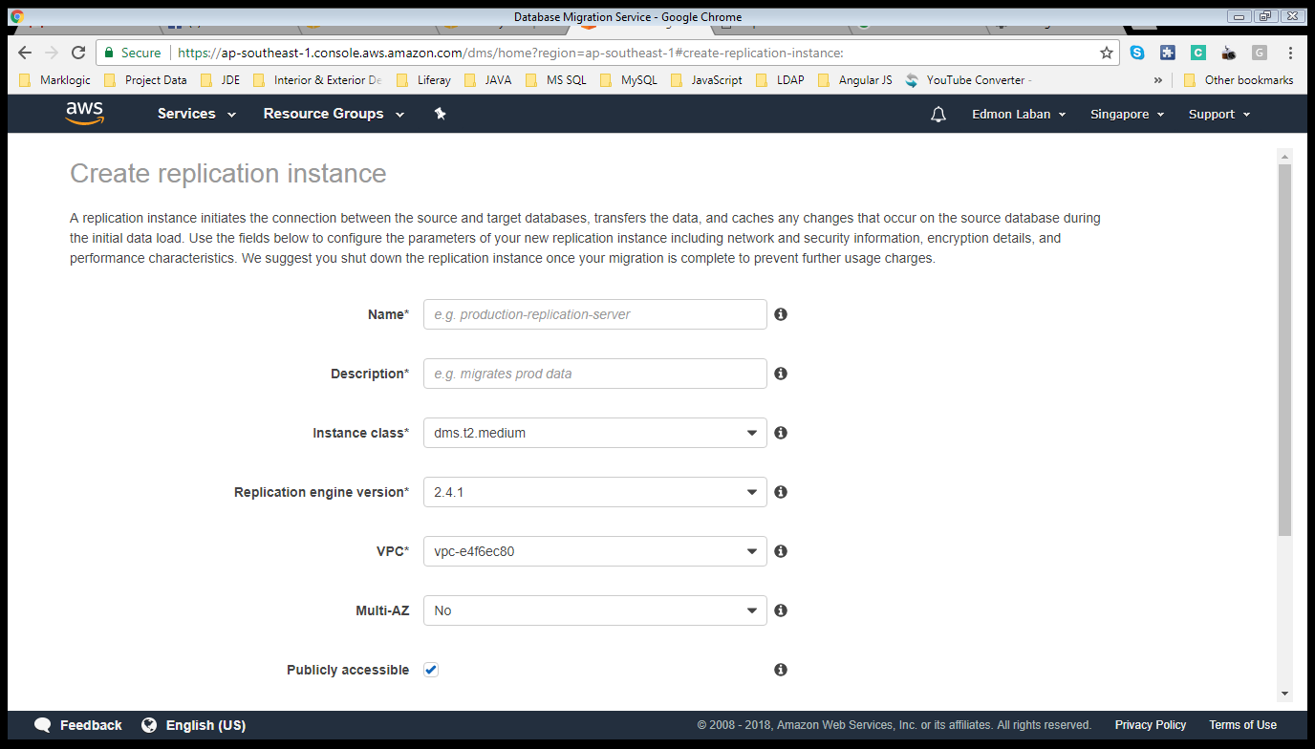

**Name:** Specify a name that is unique for all replication instances owned by your AWS account in the current region. This identifier is case insensitive, but stored as all lower-case, as in "prod-rep-server"

**Description:** Specify a name that is unique for all replication instances owned by your AWS account in the current region. This identifier is case insensitive, but stored as all lower-case, as in "prod-rep-server"

**Instance class:** Select the instance class that allocates the computational, network, and memory capacity required by this replication instance. *(dms.t2.medium)*

**Replication engine version:** Replication instance engine version. *(2.4.1)*

**VPC:** Select the Virtual Private Cloud (VPC) that defines the virtual networking environment for this replication instance. *(vpc-e4f6ec80)*

**Multi-AZ:** Use Multi-AZ deployment to provide a highly available, redundant replication stream during ongoing replications and long migrations for fast and consistent performance.

**Publicly accessible:** Enable if you want your replication instance to have a public IP address and be able to connect to databases outside the VPC. If disabled, AWS DMS will not assign a public IP address to the Replication Instance and you will not be able to connect to databases outside of the VPC. *(default check)*

1. **Click Advanced**

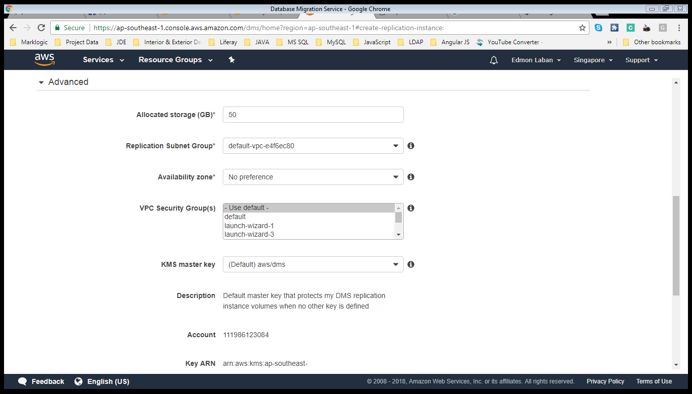

**Allocated storage (GB)*:** Storage size of instance.

**Replication Subnet Group*:** Select the replication subnet group that defines which subnets and IP ranges the replication instance can use in the Virtual Private Cloud (VPC) you selected.

**Availability zone*:** The EC2 Availability Zone that the replication instance will be created in.

**VPC Security Group(s):** Specify which security group(s) to assign to the replication instance to control outbound traffic.

**KMS master key:** This is the customer master key (CMK) that protects a data key used to encrypt this replication instance volume. You may choose either the the default key (i.e. alias aws/dms) or a customer-managed CMK created using the Encryption Keys tab on the IAM console. The default key will be available only in case replication instance is created. *(Default) ams/dms*

**Description:** Default master key that protects my DMS replication instance volumes when no other key is defined.

**Account:** (System default)

**Key ARN:** (System default)

1. **Click Create replication instance button.**

**Wait until the instance created.**

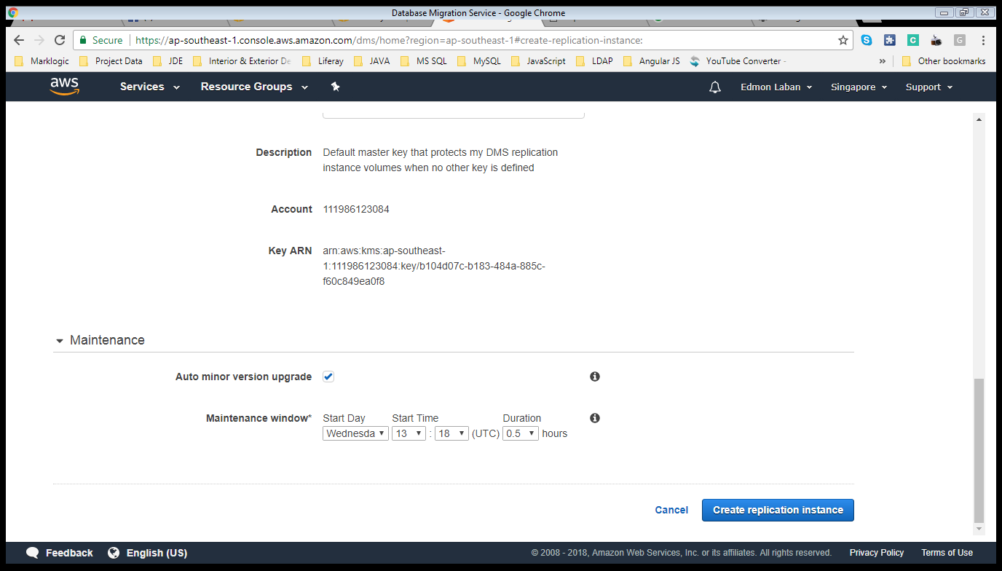

1. **Go to Endpoint.**

**Click on the side menu Endpoints button.**

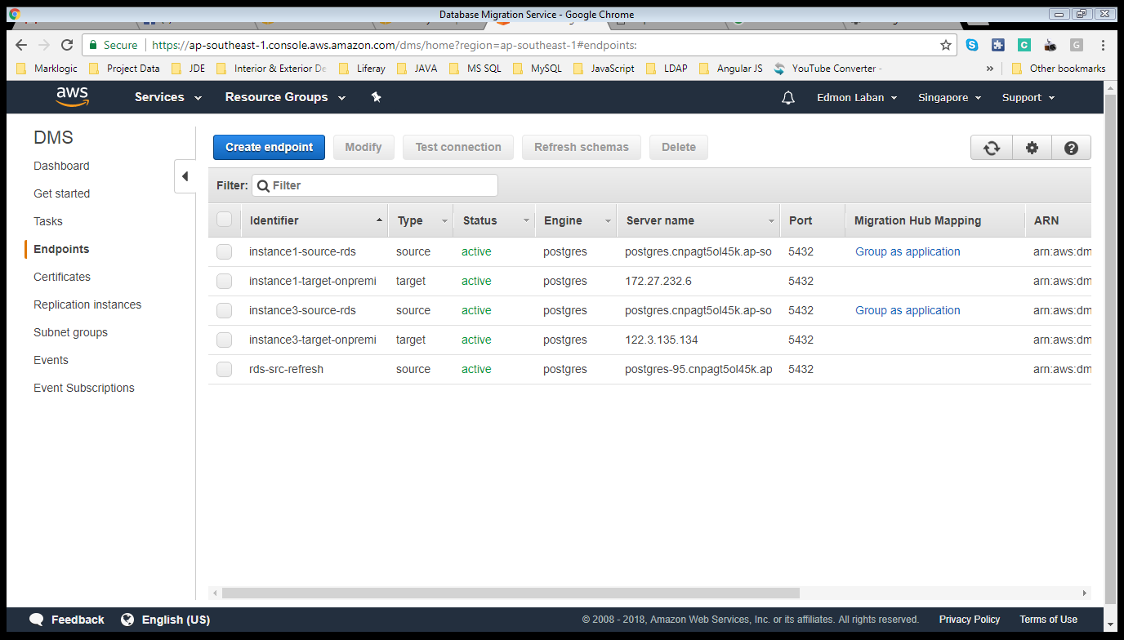

1. **Click Create Endpoint**

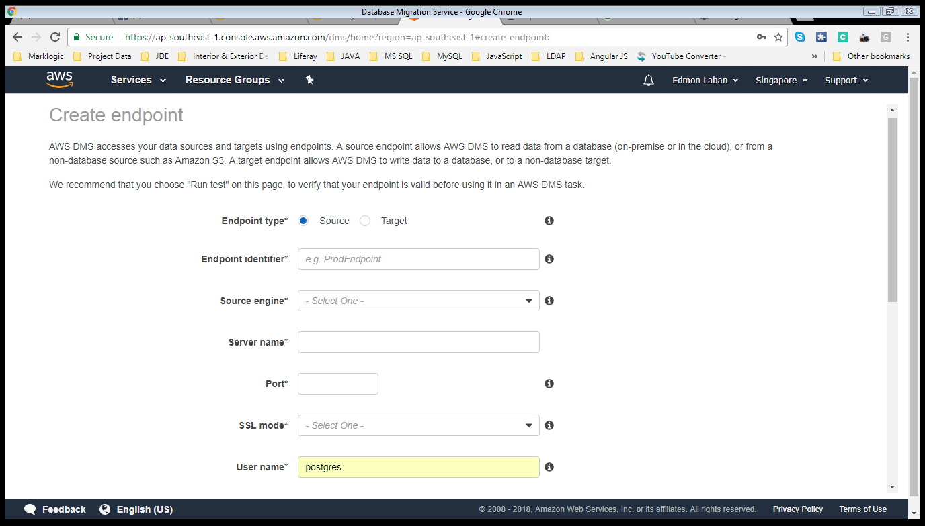

**Endpoint type*:** Select whether this endpoint will be used as a Source or a Target. A replication server can have multiple endpoints of each type *(Source or Target)*

**Endpoint identifier*:** A label for the endpoint to help you identify it. It should be unique for all replication instances owned by your AWS account in the current region *(Name of Endpoint)*

**Source engine*:** The type of database engine this endpoint is connected to. *(Postgres)*

**Server name*:** Hostname or Endpoint *(postgres-95.cnpagt5ol45k.ap-southeast-1.rds.amazonaws.com)*

**Port*:** The port the database is running on for this endpoint. *(5432)*

**SSL mode*:** The type of Secure Socket Layer enforcement. *(require)*

**User name*:** The user name with the permissions required to allow data migration. *(postgres)*

**Password*:** The user name with the permissions required to allow data migration. *(postgres)*

**Database name*:** The name of the database that will replicated or the target database.

1. **TEST ENDPOINT CONNECTION**

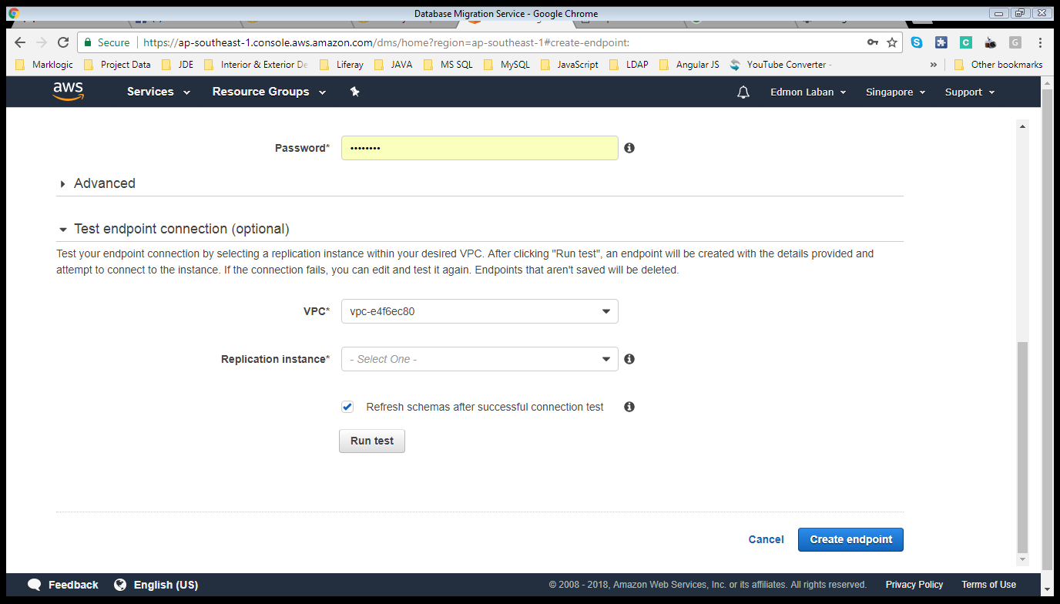

**VPC*: Select VPC *(vpc-e4f6ec80)***

**Replication instance*:** A replication instance performs the database migration.

1. **RUN TEST BUTTON**

Wait until the connection successful.

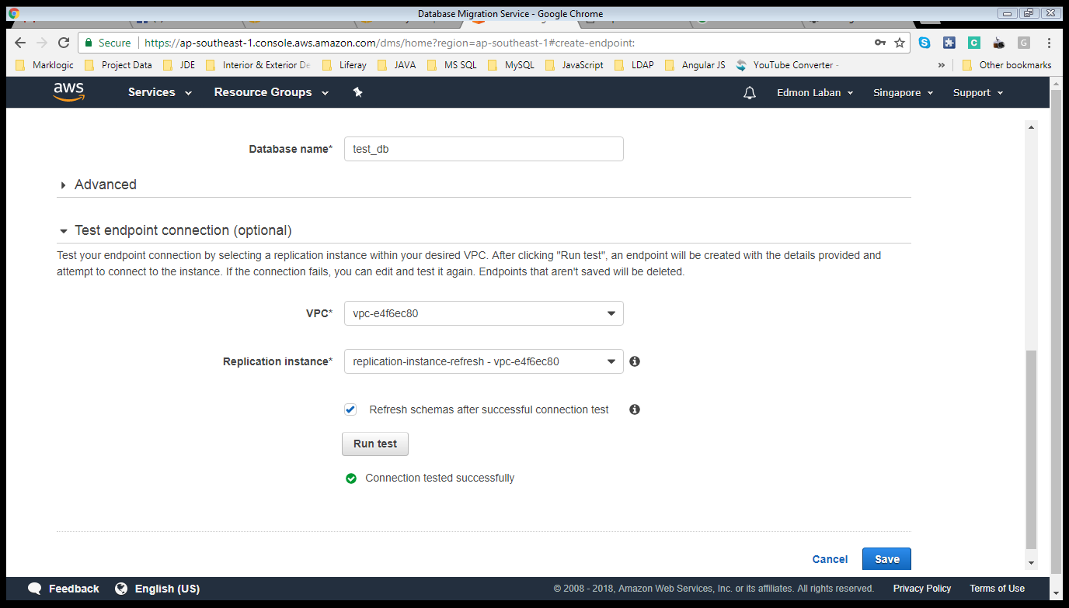

1. **CLICK SAVE BUTTON**

To create endpoint.